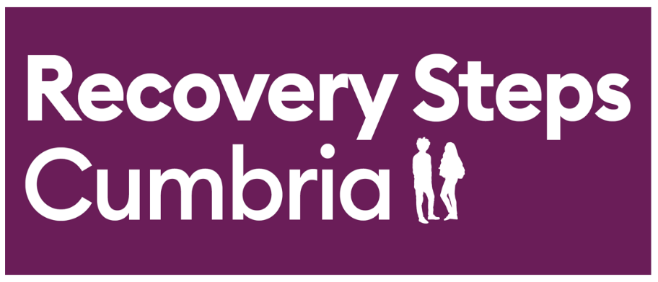

REFERRAL DOCUMENT
If you need any advice or guidance completing this document, please contact us via one of the methods below:

Office | Address
North
Carlisle  Penrith | 1st Floor, Stocklund House, Carlisle, CA3 8SY  Eden Rural Foyer, Old London Road, Penrith, CA11 8ET
West
Workington | 6 Finkle Street, Workington, CA14 2AY
Whitehaven | 21b Lowther Street, Whitehaven, CA28 7DG
South
Barrow | 92-96 Duke Street, Barrow, LA14 1RD
Kendal | White Horse Yard, 39 Stricklandgate, Kendal, LA9 4LT
Telephone : 01900 512300, select either option 1 for Carlisle / Eden, option 2 for W&W and option 3 for B&K
Email: Referrals@recoverystepscumbria.org.uk

Please send forms to referrals@recoverystepscumbria.org.uk
* Indicates a mandatory field
Personal Details
First Name* |  |  | Date of Birth*
Surname* |  | Gender (at birth) * |  | Male ☐
 |  |  |  | Female ☐
NHS Number |  |  |  | Prefer not to say ☐
 | Do you identify as the gender you were born? |  |  | Yes ☐
 |  |  |  | No ☐
 |  |  |  | Prefer not to say ☐
Date:

Address & Contact Details
Address 1* |  | Telephone Number*
Address 2 |  | Mobile Number*
Town/City |  | Email*
County |  | No Fixed Abode | ☐
Postcode*

Preferred Contact method* (please select all that apply)
Mail* ☐ Mobile* ☐
Telephone (landline)* ☐ Video conference appt* ☐
Text message ☐ Other, please specify ☐

Referrer Details
Referrer Name* |  | Referrer contact details*
Referral Source* |  | Other, please specify

Drug & Alcohol Use

Substance use (current frequency and amount)*
Give details of:
- any current/recent/past drug or alcohol use
- any previous drug/ alcohol treatment received

Date last used substance

Reason for Referral / Goal from treatment

About You

Physical/Mental Health*  Give details of:  - physical health issues  - mental health issues  - prescribed medications  involvement with mental | Are you receiving treatment for any physical health problems? If yes what
Communication/information needs* Give details of any information/communication needs such as interpreter required, large print letters, BSL, induction loop etc
Employment status *
Area of Employment
Hours of Work This is so we can try to book appointments around your working hours (if needed)
Are you pregnant / partner of someone who is pregnant?*
Are you a carer for someone else?
Do you have regular contact with U18s? For example, either those who live with you or may visit or you may visit
How safe do you feel today?
If you answered yes to any of the above questions, please provide any further details

Thank you! We will be in touch with you within 24-72 hours to explain what happens next.

