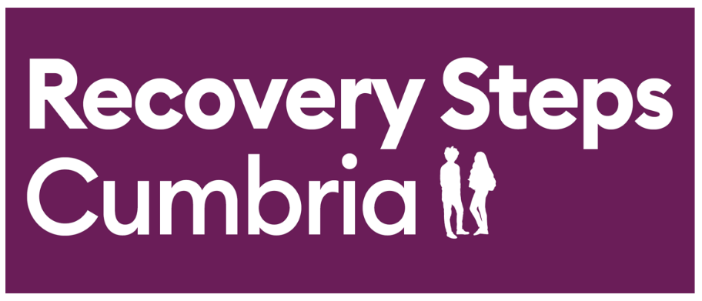

REFERRAL DOCUMENT
If you need any advice or guidance completing this document, please contact us via one of the methods below:

Office | Address
North
Carlisle  Penrith | 1st Floor, Stocklund House, Carlisle, CA3 8SY  Eden Rural Foyer, Old London Road, Penrith, CA11 8ET
West
Workington | 6 Finkle Street, Workington, CA14 2AY
Whitehaven | 21b Lowther Street, Whitehaven, CA28 7DG
South
Barrow | 92-96 Duke Street, Barrow, LA14 1RD
Kendal | White Horse Yard, 39 Stricklandgate, Kendal, LA9 4LT
Telephone : 01900 512300, select either option 1 for Carlisle / Eden, option 2 for W&W and option 3 for B&K
Email: Referrals@recoverystepscumbria.org.uk

Please send forms to referrals@recoverystepscumbria.org.uk
* Indicates a mandatory field
Referral Date:

Personal Details
First Name* |  |  |  | Date of Birth*
Surname* |  |  | Gender (at birth) * |  | Male ☐
 |  |  |  |  | Female ☐
NHS Number |  |  |  |  | Prefer not to say ☐
 | Do you identify as the gender you were born? |  |  |  | Yes ☐
 |  |  |  |  | No ☐
 |  |  |  |  | Prefer not to say ☐
Address & Contact Details
Address 1* |  | Telephone Number*
Address 2 |  | Mobile Number*
Town/City |  | Email*
County |  | No Fixed Abode | ☐
Postcode*

Referrer Details
Referrer Name* |  | Referrer contact details*
Referral Source* |  | Referrer Email*

Drug & Alcohol Use

Substance use (current frequency and amount)*
Give details of:
- any current/recent/past drug or alcohol use
- any previous drug/ alcohol treatment received

Date Last Used Substance

Reason for Referral / What is the Goal from Treatment?

About You

Physical/Mental Health*
Give details of:
- physical health issues
- mental health issues
- prescribed medications
involvement with mental services
Communication/information needs* Give details of any information/communication needs such as interpreter required, large print letters, BSL, induction loop etc
Barriers to Accessing the Service* Physical or mental health needs which could impact your ability to attend
Support Network Details of any other professionals you are currently being supported by e.g. carer, mental health services, social care etc. Please provide name(s) and contact details of all those supporting you.
Do you give us consent to contact your Support Network if needed?
Employment status *
Area of Employment
Hours of Work This is so we can try to book appointments around your working hours (if needed)
Are you pregnant / partner of someone who is pregnant?* Please provide details.
Are you a carer for someone else? Please provide details.
Do you have regular contact with U18s? For example, either those who live with you or may visit or you may visit. Please provide details.
How safe do you feel today?
If you answered yes to any of the above questions, please provide any further details or anything else you wish to share

Thank you! We will be in touch with you within 24-72 hours to explain what happens next.

